ch



Prepare chocolate and produce chocolate products
D1.HCC.CL2.13
D1.HPA.CL4.05
Trainee Manual






Prepare chocolate and produce chocolate products

D1.HCC.CL2.13
D1.HPA.CL4.05

Trainee Manual





Project Base
William Angliss Institute of TAFE
555 La Trobe Street
Melbourne 3000 Victoria
Telephone: | (03) 9606 2111
Facsimile: | (03) 9670 1330
Acknowledgements
Project Director: | Wayne Crosbie
Chief Writer: | Alan Hickman
Subject Writer: | Garry Blackburn
Project Manager: | Alan Maguire
Editor: | Jim Irwin
DTP/Production: | Daniel Chee, Mai Vu, Kaly Quach

The Association of Southeast Asian Nations (ASEAN) was established on 8 August 1967. The Member States of the Association are Brunei Darussalam, Cambodia, Indonesia, Lao PDR, Malaysia, Myanmar, Philippines, Singapore, Thailand and Viet Nam.
The ASEAN Secretariat is based in Jakarta, Indonesia.
General Information on ASEAN appears online at the ASEAN Website: www.asean.org.
All text is produced by William Angliss Institute of TAFE for the ASEAN Project on “Toolbox Development for Front Office, Food and Beverage Services and Food Production Divisions”.
This publication is supported by the Australian Government’s aid program through the ASEAN-Australia Development Cooperation Program Phase II (AADCP II).
Copyright: Association of Southeast Asian Nations (ASEAN) 2013.
All rights reserved.
Disclaimer
Every effort has been made to ensure that this publication is free from errors or omissions. However, you should conduct your own enquiries and seek professional advice before relying on any fact, statement or matter contained in this book. The ASEAN Secretariat and William Angliss Institute of TAFE are not responsible for any injury, loss or damage as a result of material included or omitted from this course. Information in this module is current at the time of publication. Time of publication is indicated in the date stamp at the bottom of each page.
Some images appearing in this resource have been purchased from stock photography suppliers Shutterstock and iStockphoto and other third party copyright owners and as such are non-transferable and non-exclusive. Clip arts, font images and illustrations used are from the Microsoft Office Clip Art and Media Library. Some images have been provided by and are the property of William Angliss Institute.
Additional images have been sourced from Flickr and SKC and are used under Creative Commons licence: http://creativecommons.org/licenses/by/2.0/deed.en
File name: TM_Prepare_choc_&_produce_choc_products_FN_040214





Table of Contents
Introduction to trainee manual 1
Unit descriptor 3
Assessment matrix 5
Glossary 7
Introduction to Chocolate 9
Element 1: Temper couverture 13
Element 2: Prepare chocolate based fillings, coatings and decorations 23
Element 3: Prepare chocolate moulds 55
Element 4: Make moulded chocolates 61
Element 5: Coat and decorate with chocolate 67
Element 6: Store chocolate and chocolate products 71
Presentation of written work 75
Recommended reading 77
Trainee evaluation sheet 79
Trainee Self-Assessment Checklist 81

Introduction to trainee manual

To the Trainee
Congratulations on joining this course. This Trainee Manual is one part of a ‘toolbox’ which is a resource provided to trainees, trainers and assessors to help you become competent in various areas of your work.
The ‘toolbox’ consists of three elements:
- A Trainee Manual for you to read and study at home or in class
- A Trainer Guide with Power Point slides to help your Trainer explain the content of the training material and provide class activities to help with practice
- An Assessment Manual which provides your Assessor with oral and written questions and other assessment tasks to establish whether or not you have achieved competency.
The first thing you may notice is that this training program and the information you find in the Trainee Manual seems different to the textbooks you have used previously. This is because the method of instruction and examination is different. The method used is called Competency based training (CBT) and Competency based assessment (CBA). CBT and CBA is the training and assessment system chosen by ASEAN (Association of South-East Asian Nations) to train people to work in the tourism and hospitality industry throughout all the ASEAN member states.
What is the CBT and CBA system and why has it been adopted by ASEAN?
CBT is a way of training that concentrates on what a worker can do or is required to do at work. The aim is of the training is to enable trainees to perform tasks and duties at a standard expected by employers. CBT seeks to develop the skills, knowledge and attitudes (or recognise the ones the trainee already possesses) to achieve the required competency standard. ASEAN has adopted the CBT/CBA training system as it is able to produce the type of worker that industry is looking for and this therefore increases trainees’ chances of obtaining employment.
CBA involves collecting evidence and making a judgement of the extent to which a worker can perform his/her duties at the required competency standard. Where a trainee can already demonstrate a degree of competency, either due to prior training or work experience, a process of ‘Recognition of Prior Learning’ (RPL) is available to trainees to recognise this. Please speak to your trainer about RPL if you think this applies to you.
What is a competency standard?
Competency standards are descriptions of the skills and knowledge required to perform a task or activity at the level of a required standard.
242 competency standards for the tourism and hospitality industries throughout the ASEAN region have been developed to cover all the knowledge, skills and attitudes required to work in the following occupational areas:
- Housekeeping
- Food Production
- Food and Beverage Service
- Front Office
- Travel Agencies
- Tour Operations.
All of these competency standards are available for you to look at. In fact you will find a summary of each one at the beginning of each Trainee Manual under the heading ‘Unit Descriptor’. The unit descriptor describes the content of the unit you will be studying in the Trainee Manual and provides a table of contents which are divided up into ‘Elements’ and ‘Performance Criteria”. An element is a description of one aspect of what has to be achieved in the workplace. The ‘Performance Criteria’ below each element details the level of performance that needs to be demonstrated to be declared competent.
There are other components of the competency standard:
- Unit Title: statement about what is to be done in the workplace
- Unit Number: unique number identifying the particular competency
- Nominal hours: number of classroom or practical hours usually needed to complete the competency. We call them ‘nominal’ hours because they can vary e.g. sometimes it will take an individual less time to complete a unit of competency because he/she has prior knowledge or work experience in that area.
The final heading you will see before you start reading the Trainee Manual is the ‘Assessment Matrix’. Competency based assessment requires trainees to be assessed in at least 2 – 3 different ways, one of which must be practical. This section outlines three ways assessment can be carried out and includes work projects, written questions and oral questions. The matrix is designed to show you which performance criteria will be assessed and how they will be assessed. Your trainer and/or assessor may also use other assessment methods including ‘Observation Checklist’ and ‘Third Party Statement’. An observation checklist is a way of recording how you perform at work and a third party statement is a statement by a supervisor or employer about the degree of competence they believe you have achieved. This can be based on observing your workplace performance, inspecting your work or gaining feedback from fellow workers.
Your trainer and/or assessor may use other methods to assess you such as:
- Journals
- Oral presentations
- Role plays
- Log books
- Group projects
- Practical demonstrations.
Remember your trainer is there to help you succeed and become competent. Please feel free to ask him or her for more explanation of what you have just read and of what is expected from you and best wishes for your future studies and future career in tourism and hospitality.

Unit descriptor
Prepare chocolate and produce chocolate products
This unit deals with the skills and knowledge required to Prepare chocolate and produce chocolate products in a range of settings within the hotel and travel industries workplace context.
Unit Code:
D1.HCC.CL2.13
D1.HPA.CL4.05
Nominal Hours:
65 hours

Element 1: Temper couverture
Performance Criteria
1.1 Melt and temper couverture using correct techniques and temperatures
1.2 Maintain tempered couverture for use

Element 2: Prepare chocolate based fillings, coatings and decorations
Performance Criteria
2.1 Select required commodities according to recipe and production requirements
2.2 Use appropriate equipment to prepare chocolate based fillings, coatings and decorations
2.3 Use correct techniques to produce chocolate based fillings, coatings and decorations to enterprise standards
2.4 Produce chocolate based fillings/centres, coatings and decorations to enterprise requirements and standards

Element 3: Prepare chocolate moulds
Performance Criteria
3.1 Ensure moulds are clean
3.2 Polish moulds ready for use
3.3 Keep moulds at correct temperature for production

Element 4: Make moulded chocolates
Performance Criteria
4.1 Select and prepare combinations to be produced
4.2 Use tempered couverture and set in moulds correctly
4.3 Fill moulded chocolates correctly
4.4 Set, release and handle moulded chocolates appropriately

Element 5: Coat and decorate with chocolate
Performance Criteria
5.1 Prepare a variety of chocolate coating, icing, glazes and decorations
5.2 Decorate using coating, icing, glazes and decorations according to standard recipes and/or enterprise standards and/or customer requests

Element 6: Store chocolate and chocolate products
Performance Criteria
6.1 Store at correct temperature and conditions
6.2 Maintain maximum eating quality, appearance and freshness

Assessment matrix
Showing mapping of Performance Criteria against Work Projects, Written Questions and Oral Questions
The Assessment Matrix indicates three of the most common assessment activities your Assessor may use to assess your understanding of the content of this manual and your performance – Work Projects, Written Questions and Oral Questions. It also indicates where you can find the subject content related to these assessment activities in the Trainee Manual (i.e. under which element or performance criteria). As explained in the Introduction, however, the assessors are free to choose which assessment activities are most suitable to best capture evidence of competency as they deem appropriate for individual students.
 |  |  | Work Projects | Written Questions | Oral Questions
Element 1: Temper couverture
1.1 | Melt and temper couverture using correct techniques and temperatures |  | 1.1 | 1, 2, 3, 4,  5, 6, 7 | 1
1.2 | Maintain tempered couverture for use |  | 1.2 | 8 | 2
Element 2: Prepare chocolate based fillings, coatings and decorations
2.1 |  | Select required commodities according to recipe and production requirements | 2.1 | 9, 10 | 3
2.2 |  | Use appropriate equipment to prepare chocolate based fillings, coatings and decorations | 2.2 | 11 | 4
2.3 |  | Use correct techniques to produce chocolate based fillings, coatings and decorations to enterprise standards | 2.3 | 12 | 5
2.4 |  | Produce chocolate based fillings/centres, coatings and decorations to enterprise requirements and standards | 2.3 | 13, 14, 15,  16, 17 | 6
Element 3: Prepare chocolate moulds
3.1 | Ensure moulds are clean |  | 3.1 | 18 | 7
3.2 | Polish moulds ready for use |  | 3.2 | 19 | 8
3.3 | Keep moulds at correct temperature for production |  | 3.3 | 20 | 9
Element 4: Make moulded chocolates
4.1 |  | Select and prepare combinations to be produced | 4.1 | 21, 22 | 10
4.2 |  | Use tempered couverture and set in moulds correctly | 4.2 | - | 11
4.3 |  | Fill moulded chocolates correctly | 4.3 | 23 | 12
4.4 |  | Set, release and handle moulded chocolates appropriately | 4.4 | 24 | 13
Element 5: Coat and decorate with chocolate
5.1 | Prepare a variety of chocolate coating, icing, glazes and decorations |  | 5.1 | 25 | 14
5.2 | Decorate using coating, icing, glazes and decorations according to standard recipes and/or enterprise standards and/or customer requests |  | 5.2 | 26 | 15
Element 6: Store chocolate and chocolate products
6.1 |  | Store at correct temperature and conditions | 6.1 | 27, 28 | 16
6.2 |  | Maintain maximum eating quality, appearance and freshness | 6.2 | 29 | 17

Glossary
Term | Explanation
Bain Marie | Water bath used for keeping food warm
Cocoa Powder | The finely grown cocoa-press cake still containing a modest amount of cocoa butter
Compound Chocolate | Cocoa butter is replaced with hardened vegetable fat, which has similar melting characteristics to cocoa butter. The cocoa mass is replaced with a strong defatted cocoa powder
Condensed Milk | Milk that has had water removed and sugar added. Very thick and sweet
Couverture | Product manufactured with cocoa butter, cocoa mass, milk powder, sugar and flavouring. (chocolate)
Cream Fondant | Sugar and glucose with added flavourings
Dark Chocolate | Chocolate mass, cocoa butter, sugar, lecithin and flavours
Drinking Chocolate Powder | Cocoa powder with some icing sugar added
Emulsifier | A substance that will help the mixing of two products that don’t normally mix such as oil and water
Enrobed Chocolate | A centre is produced first then covered in chocolate
Fat | A mixture of triglycerides. Normally solid at room temperature
Fat Bloom | A yellowish to greyish-white coating on the surface of the chocolate
Ganache | Mixture of fresh cream and couverture
Gianduja | Chocolate praline filling. Prepared from nuts or almonds, sugar and milk or plain chocolate
Hygroscopic | Absorbs moisture
Invert Sugar | Mixture of dextrose and fructose in approximately equal proportions, created by treating sucrose with an enzyme – Sucrose +Water = Dextrose +Fructose
Maillard Reaction | A chemical reaction resulting in browning, usually caused by the interaction of proteins and carbohydrates
Marzipan | Sugar mixed with almonds then milled and pasteurised
Milk Chocolate | Chocolate mass, cocoa butter, sugar, milk powder, lecithin and flavours
Moulded Chocolate | A shell is produced first, filled with a liquid, semi liquid or even firm fillings and later back (sealed) with chocolate
Nougat | Whipped white of egg, boiled sugar and honey, with almonds, nuts and candied fruit
Praline | Almonds and hazelnuts crushed finely and caramelised and mixed with milk chocolate. This paste is used in numerous confections of chocolate
Sugar Bloom | A grey bloom which is generally caused by dampness or condensation dissolving the surface of chocolate which recrystallises on drying
Tempering Kettle | Vessel used for heating chocolate working on the warm air principle where it is protected from water and steam
Truffles | A ganache with added butter
White Chocolate | Cocoa butter, sugar, milk powder, lecithin and flavours

Introduction to Chocolate
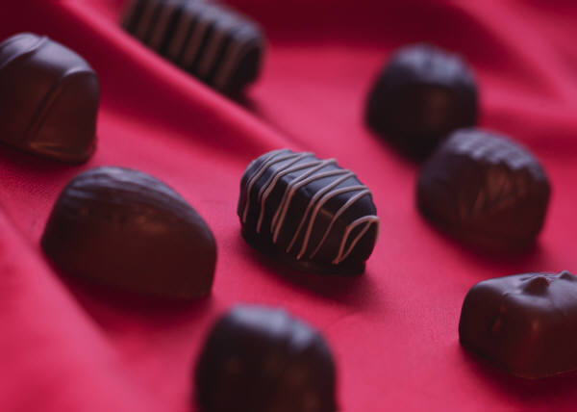
Chocolate is derived from the cacao bean. Originally from Central America and used by the Aztecs, it was bought to Europe by Cortez, the Spanish Explorer.
Originally only to be consumed by the Spanish Royal Court its secrets slowly filtered throughout Europe.
European Chocolate manufacturers slowly developed their versions in the 18th century as did the Americans with their own version of the European Style.
Both styles are now all over the world with the European Courverture Chocolate being the benchmark of finest available.
These are not the only styles; Mexican 'Chocolat' is probably closest to the original enjoyed by the Aztecs of Central America, it is very bitter and is enjoyed as a drink and used in Savoury cooking with meats in dishes called 'mole' along with 'ancho' chillies.
Chocolate as it is known in Europe has the following ingredients:
- Cocoa solids
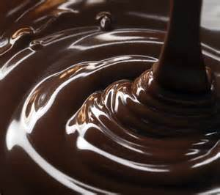
- Cocoa butter
- Sugar
- Milk Solids and butter fats
- Lecithin; acts as emulsifier; derived from soy
- Flavourings.
There are legal definitions of chocolate:
- Chocolate means the confectionary product characterised by the presence of cocoa bean derivatives:
- Prepared from a minimum 200 gm/kg of cocoa bean derivative; and
- Which contains no more than 50 gm/kg of edible oils, other than cocoa butter or dairy fats.
Chocolate confections from England could not be called chocolate because to process of making was different to European process.
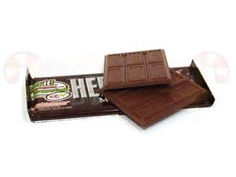
This was overturned in the European Trade Courts and now English confections made with English Style chocolate can be called chocolates rather than chocolate confectionary.
Mars and Hershey from USA are also different to European Chocolate but are still considered 'Chocolate'.
Hershey's unique flavour was by accident, overnight the milk fats fermented and developed in flavour. When released people enjoyed the flavour so the process continued.
Hershey became popular due to it being included in US Army rations during the European conflict in 1917 so when troops returned home demand for the same product grew.

Warmer Climates Chocolates
Fine European Couverture has only recently been enjoyed in warm tropical climates with the growing use of air conditioning or air climatising equipment.
Chocolate melts in the mouth so temperatures above 25°C are not good to chocolate when being stored.
Special fats were developed with higher melting temperatures for these climates and had a waxy feel in the mouth. It takes longer for the body to break these fats down so they have a tackier mouth feel.
Chocolate is available in many forms but Chocolate coverture comes in 3 styles:
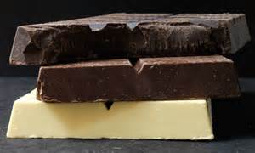
- Dark, Chocolate
- Milk Chocolate
- White Chocolate.
From these base products the confectioner applies their craft to develop products for sale to the public.
Many chocolate companies have released less sweet products onto the market place and are now adding chillies, coffee, citrus zest and even cacao nib into dark and bitter styles of chocolate with 70% to 90% cocoa solids.

The cocoa tree
Home of the cocoa tree is the northern part of South America.
The Aztecs of Mexico and the Incas from Peru produced a drink made from cocoa beans, water, honey, vanilla and spices which they called ‘Chocolatl’, and which they drank cold.
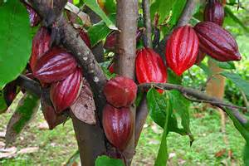
In 1520 Cortez brought cocoa beans to Spain where the Spaniards added sugar to improve the flavour of the ‘Chocolatl’.
It took many centuries of developing the quality chocolate that we take for granted today.
On its way from cocoa bean to chocolate the raw material cocoa bean passes through many stages.
Cocoa is grown in tropical climates approximately 20° north and south of the equator in areas of high rainfall and humidity.
Main producer countries are the Ivory Coast, Brazil, Ghana, Nigeria, Cameroon, Malaysia, etc.
The cocoa tree bears fruit pods twice a year. The fruit pods, which are about the size of a paw-paw, contain about 50 beans.
The fruit pods are carefully opened and the fruit flesh with the seeds (beans) scooped out and fermented.
The next step is to dry the seeds and then they are ready for shipment. During fermentation the cocoa flavour is developed.

Production of cocoa and chocolate
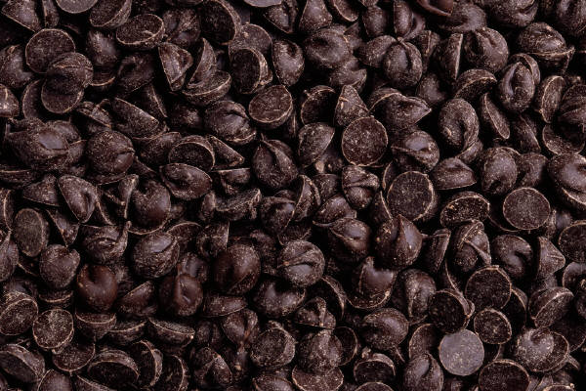
The cocoa beans are roasted, ground into a paste which is now called cocoa liqueur. This cocoa liqueur contains 50 – 55% fat, (cocoa butter).
The cocoa butter is separated from the cocoa mass in strong presses. The remaining cocoa-press cake, when ground and sifted, gives us our cocoa powder.
For making chocolate, sugar and milk powder is added to the cocoa mass as well as extra cocoa butter and flavours. All this is mixed together and milled to the desired fineness.
The next step involves conching. In the conching machine the mass is rolled and kneaded for up to 24 hours during which time the chocolate becomes smoother and the characteristic chocolate flavours are developed.
At the end of this process the chocolate is ready to be shaped into blocks or buttons, ready for further processing.
Essentially chocolate is a fine dispersion of particles in vegetable fat. The particles:
- Sugar
- Cocoa solids
- Non-fat milk solids (milk powder).
Give more flavour and sweetness to the chocolate. The vegetable fat or cocoa butter is responsible for the texture, palatability and flavour release characteristics of the chocolate.

Storage
Expert preparation of chocolate begins with proper storage:
- Storage temperature: 15°C – 18°C.
Large variations of temperature affect the fine chocolate aroma and create condensation, which crusts or thicken the chocolate.
Therefore, protect your chocolate from temperature changes, light, foreign odours, warmth and humidity.
When chocolate arrives at the processing area (kitchen etc.) from its storage area, the difference in temperature must not exceed 6°C – 7°C.

Compound chocolate
Compound chocolate, sometimes called bakers chocolate was primarily designed as a coating for baked products.
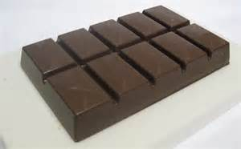
The ingredients of compound chocolate are cocoa powder, sugar and hydrogenated coconut and palm kernel oil, which are lauric fats.
These fats are incompatible with cocoa butter, which is non-lauric and must not be mixed.
Compound chocolate is available in a dark and milk variety, the milk compound containing an amount of milk solids.
Most compound chocolates are melted at temperatures similar to chocolate.
Best gloss is achieved when used at temperatures between 40 and 50°C and cooled rapidly.
Slow cooling will result in a dull sheen and fat bloom. To be coated, cakes must be cool and not still warm from the oven.
Thinning can be done with copha, (a lauric fat) or any lauric based cocoa butter substitute, (CBS), as the hardened coconut and palm kernel oils are called.

Element 1:
Temper couverture

1.1 Melt and temper couverture using correct techniques and temperatures

Melting
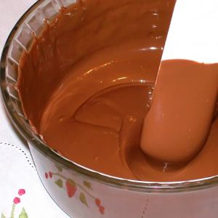
Melting temperature for chocolate is around 45°C – 50°C.
If the chocolate arrives in blocks it is advisable to cut it up into small pieces. The finer the chocolate is cut the quicker it will melt. If the chocolate arrives in buttons it can be melted immediately.
Ideally chocolate is melted in a special ‘tempering kettle’ working on the warm air principle, where it is protected from water and steam.
Chocolate can also be melted over a ‘bain-marie’ (water bath) but watch out for steam and overheating:
- The water must not boil and frequent stirring is important.
When all the chocolate is melted, the temperature must not exceed 50°C for dark and 45°C for milk and white chocolate.
Remove the chocolate pot from the water bath and wipe all the moisture off the bottom of the bowl.

Microwave ovens
Microwave ovens are well suited to melt small amounts of chocolate with speed and accuracy.
Depending on the size of the oven, 500 – 1000 grams of finely chopped chocolate is placed in a microwave safe bowl with straight sides.
Deposit the bowl off centre onto the turntable and heat for 1 minute on ‘medium’. Stir the chocolate and repeat this procedure one more time:
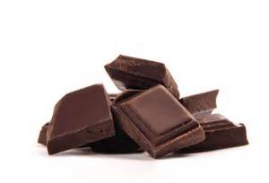
- Use a thermometer to check the temperature.
If the chocolate is still not quite melted use 10-second intervals on a ‘high’ setting until the desired temperature is achieved.
To obtain chocolate tablets of covered confectionery of good colour, texture and in a stable form so that fat bloom will not develop on the surface during storage, the chocolate must be tempered.

Tempering
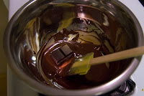
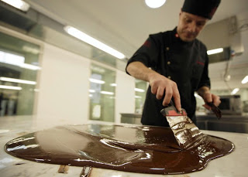
This process is necessary as a preliminary to all other chocolate proceedings. It ensures that the cocoa butter component is seeded and that the chocolate will set in a stable form with a good permanent colour and gloss.
Tempering the chocolate is important to achieve the following criteria in the end product:
- Snap when broken
- Hard bite of the coat
- Shiny gloss
- Soft melting in the mouth
- Shelf life
- Reduce fat bloom.
Tempering requires sufficient heat transfer to the chocolate to liquefy the cocoa butter and assist the development of approximately 10% of small well-dispersed crystals.
The rate of temper is generally affected by the amount of cocoa butter and the crystal formation.
The chocolate mass needs to be cooled gradually in order to form stable crystals.
The masses are passed through tempering stations for this purpose, where they are gradually cooled down from approximately 45°C to about 28°C, and reheated again to about 30°C.
Tempering affects the regular structure of the chocolate mass, resulting later in the required soft melting, snappy bite and beautiful gloss.
Over tempering will produce a thicker coating material and affect the coating on the finished product.
Under tempering will reduce the viscosity and produce a thinner coating on the centre.

Thinning of couverture chocolate
Couverture chocolate can be thinned by adding extra cocoa butter. The cocoa butter is melted in the same way as chocolate couverture.
Cocoa butter must be added and stirred into the chocolate before tempering.

Methods of tempering chocolate
The larger specialist confectioner may use fully automatic tempering tanks.
Pastrycooks, pâtissier, bakers or cooks will generally use one of the following methods:
- Direct warming method
- Injection or addition method
- Tabling, manipulation or slab method.

Direct Warming Method
As most manufacturers of couverture will temper their products, it is possible to carefully melt this chocolate and retain the original temper.
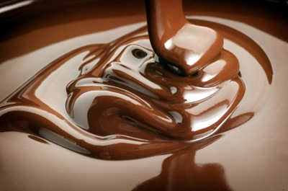
Only a very gentle application of heat to first soften then dissolve the chocolate will retain the temper. When dissolved, the chocolate must be occasionally well stirred and must not exceed 32°C.
Tempering kettles with thermostats or warming cupboards are well suited for this method, as the chocolate can soften very slowly overnight.
At about 27°C it will take on a dough-like consistency and soften further with increased warming to 30°C – 32°C.
A test should now confirm that the chocolate is ready for use.

Injection or Addition Method
Part of the chocolate is completely dissolved (45°C – 48°C), then finely chopped, grated or shaved correctly-tempered chocolate is added and stirred until the desired working temperature is reached (30°C – 32°C).
The chocolate can now be tested for correct setting properties and used.
Always keep grated, chopped or shaved chocolate well covered or sealed, as the increased surface area becomes easily contaminated by moisture or dust, thus hindering easy and complete dissolving.

Tabling, Manipulation or Slab Method
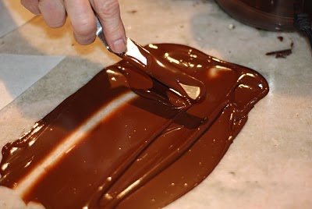
A thick marble, granite or similar slab is required for this method, in order to cool the warmed chocolate without the slab itself warming up too much.
About two thirds of the completely dissolved chocolate (45°C – 48°C) is poured on to a slab and spread to be 10 –15 mm thick.
The chocolate is now constantly worked by scraping it together and spreading it out again and the cocoa butter seed crystals are formed as the chocolate comes into contact with the cold marble.
Scraping them off the marble surface will distribute the crystals through the rest of the chocolate.
This is carried out repeatedly with a flexible palette knife, spatula or scraper. The seeding is complete when the chocolate starts to thicken (about 26°C).
The manipulated chocolate is added back to the warmed portion and is now stirred until smooth.
Stirring the couverture aims at distributing the seed crystals without incorporating air into the chocolate, and rendering it foamy.
The chocolate should now register 30°C – 32°C. After gentle heating the chocolate is tested for setting properties and should now be ready for use.
If correct temper is not achieved straightaway, the process has to be repeated until satisfactory.
ANTA: Prepare chocolate and chocolate confectionary

Typical dark chocolate tempering profile
- 50°C all crystals melted
- 30°C – 31°C working temperature
- 27°C cooled temperature
- 20°C room temperature
- 18°C storage temperature.

Fundamental rules of chocolate preparation

Tempering procedures
Pour two-thirds of the melted chocolate out on a marble slab.
Spread it out with a spatula and bring it from the outside to the centre.
This process must never be interrupted until the chocolate has the consistency of freshly cooked custard and a temperature of 26°C – 27°C.
Immediately return the cooled chocolate to the one-third chocolate left in the bowl and mix well:
- Check the temperature with a thermometer.

Desired temperature:
- Dark chocolate 30°C – 31°C / Milk chocolate 28 °C – 29°C / White chocolate
28°C – 29°C
- If the chocolate is still too warm, temper again
- If the chocolate is right go ahead with your work
- If the chocolate is too cold, gently heat it, degree for degree, controlling the temperature climb constantly with a thermometer.

Fault in chocolate
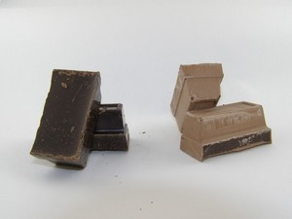
Fat bloom is recognised as a yellowish to greyish-white coating on the surface of the chocolate.
This is caused by:
- Bad tempering
- Incorrect cooling
- Presence of fat incompatible with chocolate
- Warm storage conditions cold centres.
Sugar bloom is a grey bloom, which is generally caused by dampness or condensation dissolving the surface of chocolate, which recrystallises on drying.
This is caused by:
- Damp conditions
- Dew (moisture in cool air)
- Hygroscopic (water absorbing) ingredients
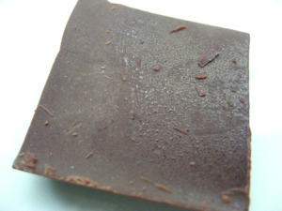
- Condensation caused by cool storage.
Overheating of chocolate will result in:
- Loss of fine flavour
- Lack of smoothness.
Air bubbles in chocolate will result in:
- Thick chocolate
- Poor gloss.
Water in chocolate will result in:
- Thick chocolate.

1.2 Maintain tempered couverture for use

Introduction
Maintain tempered couverture while working with product
Chocolate needs to be kept at a consistent temperature so there may be a need to use what is referred to as a ‘static temperature’ chocolate warmer.
These are simply a ‘dry’ bain-marie that will hold the chocolate at a temperature of approximately 32°C after it has been tempered.
Alternative is to wrap the base of bowl that the chocolate in insulation material to reduce the heat loss from the bottom of the bowl.
If the chocolate gets too cool there will be problems. The chocolate will need to be re-heated slowly over warm water or placed in chocolate bain-marie.
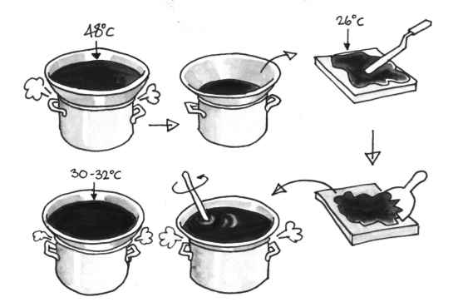
Process of Tempering

ANTA: Prepare chocolate and chocolate confectionary

Work Projects
It is a requirement of this Unit you complete Work Projects as advised by your Trainer.
You must submit documentation, suitable evidence or other relevant proof of completion of the project to your Trainer by the agreed date.
For this unit the student is going to produce a selection of chocolate products.
The selection should include formed soft centre chocolates; soft centre filled; hard centre enrobed.
How the student provides evidence for these skill demonstrations is to be agreed with the Trainer.
  - Prepare and melt chocolate for tempering and then tempering a portion of chocolate couverture:
- Chocolate must not be overheated
- Chocolate must not come into contact with moisture.
1.2. Hold tempered couverture chocolate at the required temperature:
- The chocolate must be held in such a way as it will not be too thick to be manipulated successfully.

Summary

Temper couverture
Melt and temper couverture using correct techniques and temperatures
Cut the chocolate into very fine particle sizes
Place into a dry clean bowl and place over warmed water and allow to soften
Do not allow temperature to rise above 50°C
Stir with a dry spoon until all chocolate pieces have melted
Follow one of the tempering procedures:
Tabliering
Seeding.
Maintain tempered couverture for use
Keep warm at constant 32°C
If the temperature falls below 26°C warm slightly over warm water.

Element 2:
Prepare chocolate based fillings, coatings and decorations

2.1 Select required commodities according to recipe and production requirements

Filled chocolate
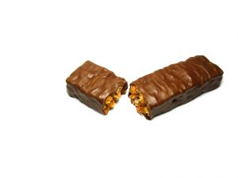
Filled chocolate are produced in two different ways.
A centre is produced and then enrobed with chocolate. Suitable are centres that have thermal stability and may or may not soften on storage.
Suitable fillings for enrobed chocolate are:
- Marzipan
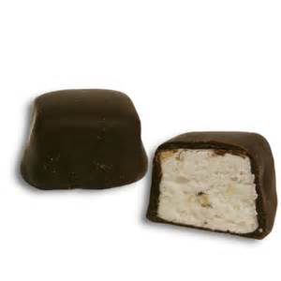
- Ganache
- Nougats
- Croquants (Praline) hard, soft, laminated
- Fondants
- Glace fruit.

Moulded chocolates
Here a shell is produced first, filled with a liquid, semi liquid or even firm fillings and later back (sealed) with chocolate.
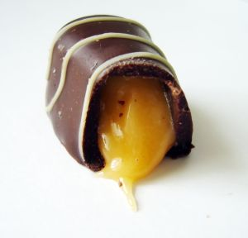
Suitable fillings for moulded chocolates are:
- All fillings that are soft enough to be deposited:
- Liqueurs
- Ganache
- Praline paste (nutella)
- Crèmes
- Fondants.

Before you start, ensure all your ingredients, utensils and required workspace are suitable and available.
- Make sure you have correctly weighed and measured the ingredients
- Check that saucepans and mixing bowls are the correct se and ready to use
- Ensure your required work surface is clean and dry
- Check that you have all the utensils at hand for preparing your recipes
- Check that the moulds are clean, polished and at the correct temperature
- Always test couverture for correct temper and setting properties prior to use
- Plan a logical and rational flow when setting up your workstation
- Select an odour-free storage area with desired temperature and humidity levels.

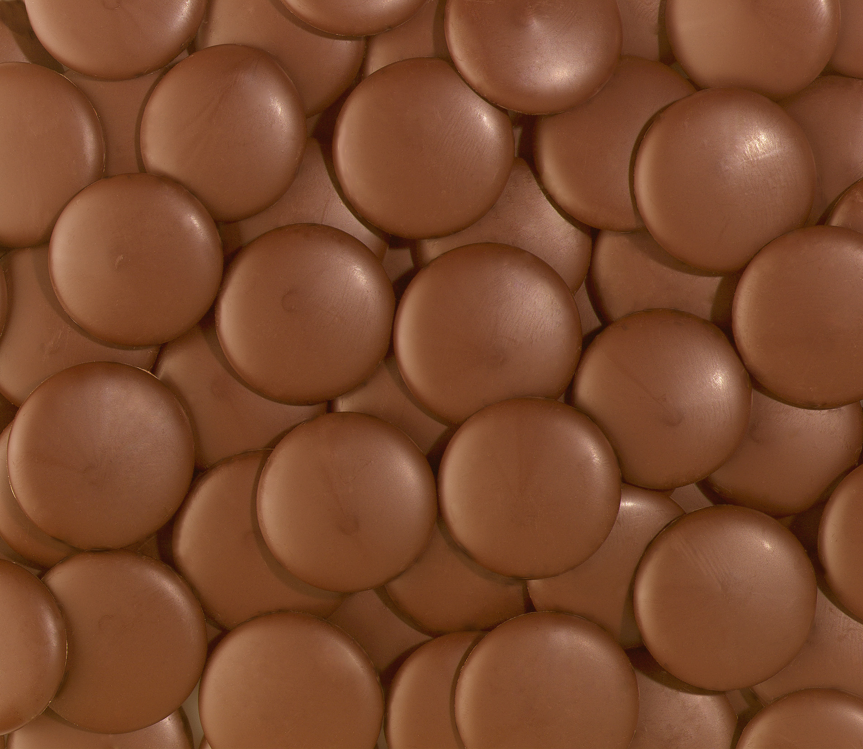
Couverture Chocolate
This is the definition of true European Chocolate. Available in dark or milk variation and will include no lauric fats, just cocoa butter and varying levels of sugar and milk in milk chocolate.

Compound chocolate
Compound chocolate, sometimes called bakers chocolate was primarily designed as a coating for baked products.
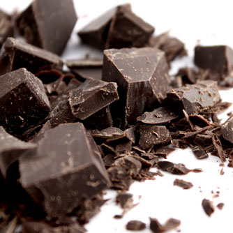
The ingredients of compound chocolate are cocoa powder, sugar and hydrogenated coconut and palm kernel oil, which are lauric fats:
- These fats are incompatible with cocoa butter, which is non-lauric and must not be mixed.
Compound chocolate is available in a dark and milk variety, the milk compound containing an amount of milk solids.
Most compound chocolates are melted at temperatures similar to chocolate. Best gloss is achieved when used at temperatures between 40°C and 50°C and cooled rapidly:
- Slow cooling will result in a dull sheen and fat bloom.
To be coated, cakes must be cool and not still warm from the oven.
Thinning can be done with copha, (a lauric fat) or any lauric based cocoa butter substitute, CBS, as the hardened coconut and palm kernel oils are called.

Thinning of chocolate
Chocolate can be thinned by adding extra cocoa butter. The cocoa butter is melted in the same way as chocolate.
Cocoa butter must be added and stirred into the chocolate before tempering.

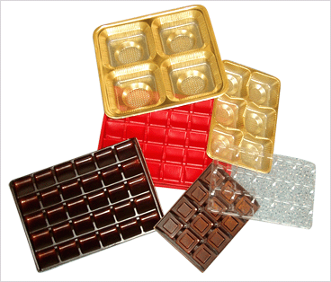
2.2 Use appropriate equipment to prepare chocolate based fillings, coatings and decorations

Introduction
Equipment may include:
Trays
- Trays for filled moulds
- Trays for demoulded chocolates.
All these trays will have to food standard. Trays in professional organisations need to be the same size.
Trays are used to carry several moulds for ease of handling:
- Rather than making four trips to cooling area it is easier to make one.
Racks
Are required for holding trays and if on wheels makes moving around the kitchen easier.
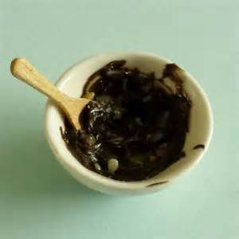
Bowls
Various sizes are required for mixing ingredients and holding tempered chocolate. Stainless Steel is recommended but good quality food grade plastic or polycarbonate.
Mixing machine
Some of the fillings may have to be mixed before they are incorporated into the chocolate.
Scales
Electronic scales are modern equivalent of older style balance scales. No matter the types used they need to be calibrated to ensure recipe consistency and formula balance.
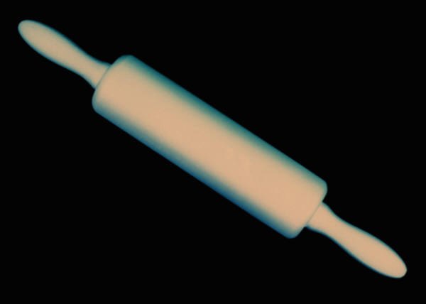
Rolling pins
Rolling pins are used to roll pastes to a consistent thickness and this is best achieved by using bars either side of the paste that is the required thickness.
Moulds
Moulds of various types will be required.
Polycarbonate is the modern standard as the old tinplate was harder to keep clean and rust free.
Rings
Many shapes may be required to hold molten fillings to shape until setting has been achieved.

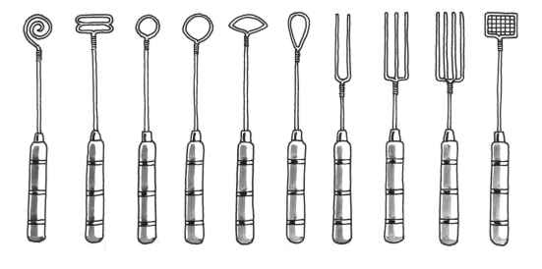
Dipping tools and racks
A Selection of Chocolate Dipping Forks
These dipping forks are used by dropping the centre into the chocolate and using the fork to lift the centre out and place onto tray.
The fork can sometimes be used to decorate the top of the dipped chocolate before the coating hardens.

2.3 Use correct techniques to produce chocolate based fillings, coatings and decorations to enterprise standards
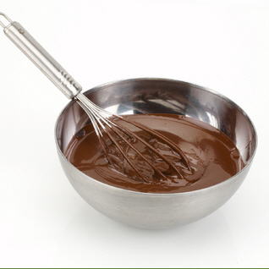
Techniques may relate to:
Whisking
Using a wire whisk to emulsify melted couverture and boiled cream to make ganache.
Folding
Gentle motion of combining two or more ingredients.
Piping
Using a piping bag to fill preformed ganache moulds and chocolate moulds with flavoured fillings.
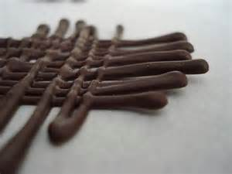
Flooding
A technique where the outline of a shape is traced with one colour chocolate and then the space inside is filled with another of contrasting colour. The drawing needs to be 'reversed out' or turned over to reveal the true picture.
Stencilling
Modern styles for this are on pre-printed acetate. These are cut to size and placed on chocolate pieces while chocolate is still wet.
When the chocolate sets the acetate is peeled off leaving the design imprinted on the chocolate.
Enrobing
Covering completely in chocolate to encase a product.
Can be done by hand or on conveyer belt enrobers attached to cooling tunnels to cure or set the chocolate so it can be safely handled with gloved hands.
It is important to handle chocolate pieces with a glove covering the hands due to the oil in the human skin can leave a 'mark' on the sheen of chocolate.
Depositing
The action of placing chocolate into moulds or filling preformed shells.

Skills and Techniques
Many of the common skills required by the confectioner are also found in the pâtissier skills.
Confectionery can be a specialised area where that is all the person does but is also an area where the pâtissier can value add to the smaller venues in which they are employed.

2.4 Produce chocolate based fillings/centres, coatings and decorations to enterprise requirements and standards

Filling Procedure
- Polish the chocolate mould and warm it to 25°C – 28°C
- Temper the Couverture chocolate
- Fill the chocolate mould and shake it. This will remove possible air bubbles from the bottom of the mould
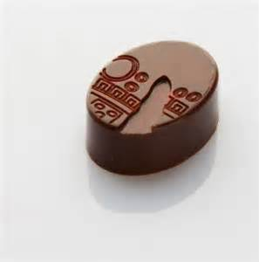
- Rest the Couverture chocolate filled mould for a few minutes to allow some of the Couverture chocolate to set on the inside of the moulds, then
- Turn the mould over and allowing the excessive Couverture chocolate to flow back into the chocolate pot
- Give the mould a few oscillating spins, and when no more chocolate flows out turn the mould over and clean it up with a scraper
- Take care not to damage the mould with metal scrapers
- Now place the mould into a cooler set the Couverture chocolate
- Prepare the filling as per recipe, remove the chocolate mould from the cooler and fill to 2mm from the top. Tap the mould to spread the filling evenly
- Place the filled chocolate mould in the cooler until the filling is firm to touch then remove from the cooler
- Warm the top of the filled Couverture chocolate mould with either a strip or fan heater, taking care not to melt the Couverture chocolate
- Cover the top of the warmed chocolate mould with tempered chocolate, top it to remove air bubbles and clean it up with a scraper. Then return the sealed chocolate mould to the cooler
- When set, place a tray on top of the chocolate mould and flip over. Tap lightly with a wooden spoon and then remove the plastic mould
- All the filled Couverture chocolates should now sit evenly spaced on the tray.

Recipe Card: Fondant Filling
Group | Ingredients | Quantity
A | Fondant | 500 gm
B | Flavour  Colour | To suit  To suit
C | Thinning syrup | To suit
Method:
- Warm the fondant to 40°C
- Add the desired flavour and colour
- If necessary thin fondant to the required consistency with thinning syrup
- Deposit fondant filling into prepared Couverture chocolate shells.
Important
Check the temperature of the fondant before depositing. It should be 32°C.

Thinning Syrup
Group | Ingredients | Quantity
A | Sugar  Water  Glucose Syrup | 500 gm  175 gm  50 gm
Method:
- Boil to dissolve sugar crystals
- Remove from the stove.
Note:
Thinning syrup is also called ‘Stock Syrup’ or ‘Bob Syrup’.

Recipe Card: Gianduja Filling
Ingredients | Weight
Praline paste (Nutella) | 200 gm
Couverture Milk Chocolate, | 160 gm
Total weight | 360 gm
Method:
- Melt chocolate to 45°C
- Warm the praline paste (40°C) and add to the chocolate. Stir till a smooth, homogenous mass is achieved
- Temper gianduja to 26°C. (This is done to stabilise the cocoa butter)
- Place the tempered Gianduja paste into a piping bag and fill Couverture chocolate lined mould to one-third
- Deposit one toasted Hazelnut into each Couverture chocolate case and push down firmly (OPTIONAL)
- Fill more Gianduja paste on top of toasted hazelnuts. Leave a gap of 2 mm from the rim to allow chocolate to be sealed
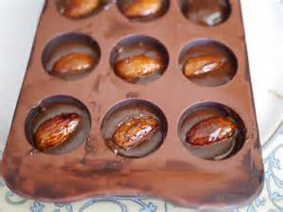
- Refrigerate (5 – 10 minutes)
- Warm the top of the Couverture chocolate, but do not over heat
- Back off with tempered Couverture chocolate
- Refrigerate 12°C – 16°C for 10 – 30 minutes
- De-mould.

Gianduja
This is a mixture of praline mass and chocolate.
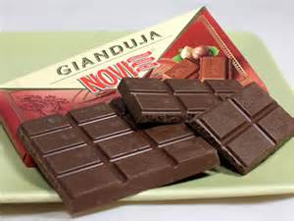
A light colour can be achieved with a light roast of units prior to refining and a milk or white chocolate.
Depending on the ratio of Praline mass to chocolate a softer or harder unit can be achieved.
The softer mix is suitable for depositing in to a shell and the harder mix can be cast into a slab, cut when set and then enrobed.

Recipe Card: Praline Filling
Ingredients | Weight
Praline paste (Nutella)  Cocoa Butter (6.5%) (can be substituted with copha) | 300 gm  20 gm
Hazelnuts (toasted) OPTIONAL | 50 gm
Yield 1 mould 3 x 8 pieces
Method:
- Melt cocoa butter to 40°C
- Add praline past to the melted cocoa butter
- Warm the mix to 40°C to dissolve all crystals. Stir to achieve a homogenous mass
- Temper gianduja to 26°C
- Place the tempered praline into a piping bag and fill Couverture chocolate lined mould to one-third
- Deposit one toasted Hazelnut into each Couverture chocolate case and push down firmly
- Fill more praline paste on top of toasted hazelnuts. Leave a gap of 2mm from the rim to allow chocolate to be sealed
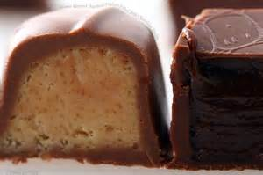
- Refrigerate (5 – 10 minutes)
- Warm the top of the Couverture chocolate, but do not over heat
- Back off with tempered Couverture chocolate
- Refrigerate for 10 – 30 minutes
- De-mould.

Praline
Praline is made from nuts (usually almonds or hazelnuts) and sugar.
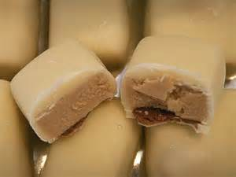
Chocolate, chocolate liqueur, milk powder etc. is often mixed with praline.
The work processes vary in accordance with the desired colour and flavour.
1. Mix roasted hazelnuts with icing sugar and refine
2. Praline
Prepare a sugar solution, boil to 120°C, and the roasted almonds, stir till the sugar has crystallised and continue to cook while stirring until the desired colour is achieved. Then cool as a slab, break up into pieces and refine.
3. Croquant
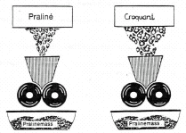
Melt sugar and mix with hot roasted almonds, cool as a sheet on a cooling table then break into pieces and refine.
Croquant
Praline
Praline mass
Praline mass
Compositions of basic praline are:
Type | Sugar | Nuts | Fat | Water
Hazelnut praline | 50% | 50% | 30% | 2%
Almond praline | 50% | 50% | 28% | 2%
Almond/Hazelnut praline | 50% | 50% | 29% | 2%

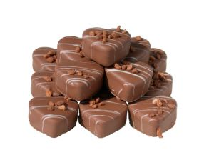
Use of Praline
The consistency of Praline may be altered with the addition of extra Cocoa Butter.
If the Praline is to be used for piping and extruding (enrobing) up to 10% of Cocoa Butter may be added to achieve certain stiffness for the product to retain its shape.
5% of cocoa Butter is required to stabilise the nut oil and to prevent fat migration.
Important:
All Praline Pastes are to be tempered before use to stabilise the fat crystals.
The higher the oil content of the mix and the lower the Cocoa Butter content, the lower must be the tempering temperature of the Praline Mass.

Ganache
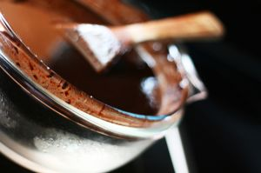
Traditionally, ganache is a mixture of fresh cream and couverture, the consistency is regulated by higher or lower additions of couverture.
A recipe with average consistency reads:
- 1 part cream (100 gm)
- 2 parts covertures (200 gm)
This ganache is easy to handle, smooth, has a balanced aroma and a tender texture:
- The fat content is about 40%.
By adjusting the couverture content up or down, it is possible achieve a consistency suitable for depositing or cutting.
The shelf life of the ganache is limited due to the relatively high water content from the fresh cream.
Although fresh cream is always pasteurised we still need to boil the cream before using it in the ganache.
The hot cream is needed to help dissolve the finely chopped couverture.
There is enough heat in one part boiled cream to dissolve two parts of couverture.

Findings
- The fat content remains even (around 38%)
- The content relates to the melting in the mouth
- The sugar content increases
- The chocolate dry matter increases
- The ganache becomes sweeter but with a stronger chocolate aroma
- The shelf life increases.

Flavouring ganache
Ganache is normally flavoured with alcohol based spirits because it will blend with the chocolate but alternatives can be used.
Because chocolate is such a dominant flavour in itself it is necessary to find other intense flavours that match.
Grand marnier or cointreau is orange based flavoured spirits that work well.
Alternative is candied orange zest with the volatile oil intact to add flavour to chocolate.
Coffee bean nibs go well into chocolate and also filling can be infused with coffee in the cream when it is boiled.
Instant coffee can be dissolved in small amount of water and added to ganache.
Chilli has become popular addition to chocolate products and fillings either as the essential heat element or infused into the cream for ganache.
Spices can be cooked into cream then used to flavour ganache.
Flavouring ganache is easy. Getting the flavour to work with the chocolate is the hard part.
Getting the public to accept this new radical flavour is even harder.
There are many alternatives to alcohol based flavours.

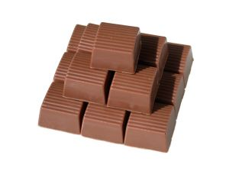
Truffles
Basically truffles are ganache mixes refined with butter.
Use 10 – 20% butter to replace chocolate.
As butter has a lower melting point, the consumer will experience a smoother mouth feel.
‘A melt in the mouth sensation’.
Comparison of 3 different types of Ganache
Ingredient | Cream | Dark  Couverture | Total | In % | Related to:
Light Ganache
Ratio: 1 : 1.5
Water | 60 gm | - | 60 gm | 24 | Shelf-life
Sugar | - | 45 gm | 60 gm | 18 | Sweetness
Fat | 35 gm | 60 gm | 45 gm | 38 | Consistency
Dry Matter | 5 | 45 gm | 95 gm | 20 | Choc. Aroma
The Recipe | 100 gm | + 150 gm | = 250 gm | 100%
Middle Ganache (praline)
Ratio: 1 : 2
Water | 60 gm | - | 60 gm | 20 | Shelf-life
Sugar | - | 60 gm | 60 gm | 20 | Sweetness
Fat | 35 gm | 80 gm | 115 gm | 38.3 | Consistency
Dry matter | 5 gm | 60 gm | 65 gm | 21.7 | Choc. Aroma
The Recipe | 100 gm | + 200 gm | = 300 gm | 100%
Heavy Ganache (Cutting)
Ratio: 1 : 2.5
Water | 60 gm | - | 60 gm | 17.1 | Shelf-life
Sugar | - | 75 gm | 75 gm | 21.4 | Sweetness
Fat | 35 gm | 100 gm | 135 gm | 38.6 | Consistency
Dry matter | 5 gm | 75 gm | 80 gm | 22.9 | Choc. Aroma
The Recipe | 100 gm | + 250 gm | = 350 gm | 100%

Recipe Card: Egg Cognac Truffle (White Chocolate)
Ganache Ball Shape using commercial truffle shells
Group | Ingredients | Quantity
A | Fresh cream (35% Butterfat) | 720 gm
B | Egg yolks  Caster Sugar | 200 gm  100 gm
C | White Chocolate, Couverture - chopped | 1000 gm
D | Cognac | 320 ml
 | Total Weight | 2340 gm
(This amount is enough for the whole class)
Method:
- Boil the cream and remove saucepan from stove
- Beat “B” and add into cream, return to stove and heat to 70°C while continuously stirring
- Add the chopped Couverture chocolate and stir till all Couverture chocolate is dissolved, add the cognac last
- Cool ganache to 26°C, stir till smooth and fill up piping bag
- Fill the Couverture chocolate shells to about 2mm from the top and allow cooling (Truffle shells)
- Seal the opening with a dot of Couverture chocolate
- Allow to set
- Coat with tempered dark Couverture chocolate and roll over a cooling wire to spike the Couverture chocolate ball.
Pre formed shells and Artisan shapes
Pre-formed commercial truffle shells are available from chocolate suppliers.
If they are not available the ganaches will have to be piped into small balls on greaseproof paper and allowed to set.
When firm they will need to be hand dipped and rolled in tempered couverture.
Hand rolled truffles are more difficult to get consistently the same size. With practice they can have artisan look with their irregular shapes.
These are best sold by weight rather than by the piece.

Chocolate Centres for Enrobing

Recipe Card: Marzipan with Kirsch
Group | Ingredients | Quantity
A | Marzipan | 750 gm
 | Kirsch Concentrate  Sugar Syrup  Soft unsalted butter | 40 ml  40 ml  40 gm
 | Total Weight | 870 gm
Method:
- Mix marzipan and kirsch concentrate
- Roll the kirsch marzipan between 15 mm steel bars and cut out shapes
- Place the shapes onto a clean aluminium tray lightly dusted with icing sugar
- Allow to stand overnight for shapes to form a skin
- Dip in dark Couverture chocolate and decorate with a 2 fork marks.

Recipe Card: Marzipan with Walnut
Group | Ingredients | Quantity
A | Marzipan 50/50  Walnut Pieces  Invert Sugar | 1,000 gm  100 gm  100 ml
B | Walnut halves for decoration | As Required
 | Total Weight | 1,200 gm
Method:
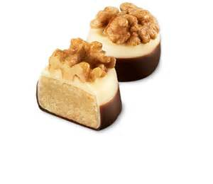
- Blend the marzipan, the crushed walnuts to a smooth mass
- Roll out between two plastic sheets to a height of 10mm
- Cut out oval shapes and place half a walnut on top before coating with Couverture chocolate
- Decorate with fine Couverture chocolate lines of contrasting colour.

Recipe Card: Truffle Base Cream
Group | Ingredients | Quantity
A | Water  Sugar | 90  190
B | Glucose syrup  Evaporated milk | 280  135
C | Butter (soft) | 600
D | Milk Couverture chocolate | 1000
 | Total Weight | 2,295 gm
Method:
Prepare Base Cream
- Dissolve the sugar in water (boil)
- Remove saucepan from the stove
- Add glucose syrup and the milk, mix thoroughly and allow to cool to room temperature
- Cream the butter and slowly add the cooled syrup
- Continue to beat/whisk, till light
- Quickly fold in the liquid Couverture chocolate (26°C)
- Pipe onto prepared Couverture chocolate wafer/discs.

Recipe Card: Roger Almonds
Ingredients
Striped Almonds lightly toasted
Stock syrup
Icing sugar
Method:
- Place the striped almonds onto a clean baking tray and toast till lightly brown (oven setting 160°C to 165°C)
- Moisten the toasted almonds with a little stock syrup (one part water and two parts sugar) taking care to moisten the almonds evenly
- Spread some icing sugar over the almonds and mix through
- Return the almonds to the oven (oven setting 160°C to 180°C) In short intervals turn over the almonds with a spatula to ensure an even toasting
- When cold take small quantities of these Roger Almonds and mix it with a little Couverture chocolate
- With a fork or spoon, place small heaps onto paper or plastic.

Recipe Card: Walnut Fudge
Group | Ingredients | Quantity
A | Sugar  Fresh cream | 500 gm  300 gm
B | Glucose syrup  Butter (salted)  Walnuts (chopped)  Seeds of one Vanilla bean | 300 gm  100 gm  200 gm  1
C | Fondant | 75 gm
 | Total Weight | 1,475 gm
Method:
- Heat sugar and cream to dissolve the sugar
- Add all ingredients to Group B
- Boil to 116°C while stirring continuously
- Pour the sugar mass between 15 mm high steel bars arranged on an oiled marble slab
- Allow to cool to 90°C
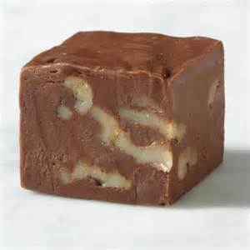
- Add the fondant
- Agitate and cream as for making Fondant. As it thickens, press the mix between 1cm high steel bars, place on plastic and allow to set
- Cut into squares, 20 x 20 cm
- Coat with milk or dark Couverture chocolate
- Decorate with fork mark.

Recipe Card: Peppermint Fondant
Group | Ingredients | Quantity
A | 1 Fondant | 1,000 gm
B | Thinning Syrup (approx) | 100 gm
C | Peppermint Oil | 2 ml
Thinning Syrup
Group | Ingredients | Quantity
A | Water | 350 gm
B | Sugar | 1,000 gm
C | Glucose Syrup | 200 gm

Method:
- Bring thinning syrup to the boil, stirring continuously, until all the sugar is dissolved
- Place the fondant into a bowl and soften gently
- Add thinning syrup and bring temperature to 74°C
- Add peppermint oil and mix in.
OPTIONAL: Add 10 drops of invertase and mix in.
- Deposit into starch trays or rubber mats
- Leave to cool, do not cover to dry completely
- Sieve out and brush ready for enrobing.

Recipe Card: Puffed Rice Gianduja
Group | Ingredients | Quantity
A | Nutella Paste  Milk Couverture chocolate | 500 gm  300 gm
B | Puffed Rice / Rice Bubbles | 75 gm
C | White Couverture chocolate  Crushed praline | 250 gm  75 gm
D | Dark Couverture chocolate for Coating
Method:
- Melt the milk Couverture chocolate to 45°C
- Stir the Nutella paste into the milk Couverture chocolate
- Temper the mix to 26°C
- Stir in the puffed rice
- Line a shallow tray with plastic and pour the mix out to a height of 10 mm
- Allow to set
- Coat the base with a thin layer of tempered Couverture chocolate
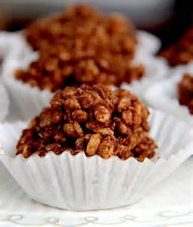
- Allow to harden and place the base back into the tray
- Temper 250 grams of white Couverture chocolate and spread over the top of the gianduja in the tray
- Just before the white Couverture chocolate hardens, cut into rectangles 20 x 30mm
- Immerse centres to the top into tempered dark Couverture chocolate to coat the bottom and sides up to the top
- Decorate with Couverture chocolate lines.

Recipe Card: Williams Truffle Sticks
Group | Ingredients | Quantity
A | Cream | 250 gm
B | Dark Couverture chocolate (chopped) | 900 gm
C | Pear William Spirit | +/- 150 ml
D | Unsalted Butter | 100 gm
 | Couverture chocolate for coating
 | Total Weight | 1,400 gm
Method:
- Boil the cream
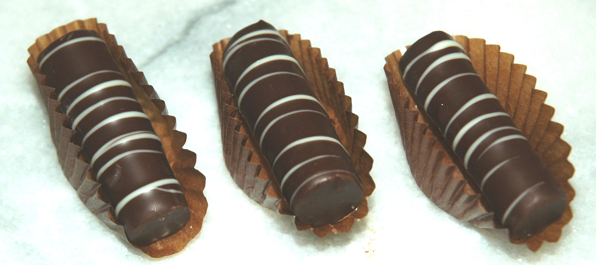
- Add the Couverture chocolate and stir until smooth
- Add the Pear William Spirit and stir till smooth and cool to 30°C
- Soften the butter (do not melt) and stir into the batch. Allow to get cold
- When set, mix the batch with a spoon ( or slow in a machine) till smooth but firm
- Using a plain tube (13mm), pipe long sticks onto greaseproof paper or plastic
- Allow to set
- Brush thinly with tempered Couverture chocolate and when set cut into 3cm sticks
- Enrobe with dark Couverture chocolate and decorate with two fork marks.
Please Note:
The flavour can be changed by varying the type of spirit.
However if alcohol is undesirable, other flavours such as coffee, vanilla etc. can be substituted.

Recipe Card: Rum Truffles (Ganache)
Group | Ingredients | Quantity
A | Fresh cream (35% butterfat) | 300 gm
B | Couverture chocolate (chopped) | 700 gm
C | Rum | 50 gm
 | Total Weight | 1,050 gm
Method:
- Bring ingredients in group A to the boil and remove from the stove
- Add to the chopped Couverture chocolate to group A and stir till dissolved
- Stir the rum from group C into the mix and allow cooling.
Finishing off:
- When the ganache is cool, beat it lightly with a hand whisk till it begins to firm up
- Then using a piping bag and a medium size plain nozzle pipe, put small heaps onto greaseproof paper and allow to firm up
- When firm roll the ganache heaps, between the palms of hands into balls
- Put some Couverture chocolate on one palm of your hand and roll the ganache balls, between palm and fingers, coating the balls with Couverture chocolate
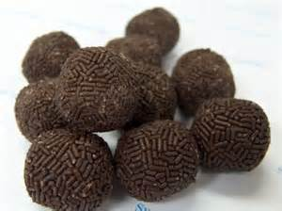
- Deposit the Couverture chocolate coated ganache balls on grease – proof paper and allow to harden.
This is necessary to create a firm Couverture chocolate crust around the still slightly soft ganache balls
- Roll a second time in tempered Couverture chocolate, place onto plastic sheets and allow hardening.
Important:
Use disposable plastic gloves when rolling the Couverture chocolate balls in liquid Couverture chocolates.

Recipe Card: Almond Brittle
Group | Ingredients | Quantity
A | Castor sugar | 600 gm
B | Butter | 140 gm
C | Bicarbonate of soda | 4 gm
D | Almond Slivered/Nibbed/Cubes (warm -roasted) | 600 gm
 | Total Weight | 1,344 gm
Method:
- Preheat a saucepan
- Melt 50g of sugar, stirring all the time, when golden and liquid add another 50g of castor sugar and melt. Continue like this until all the sugar is melted)
- Add butter and stir in
- Add bicarbonate of soda and stir in
- Pre-heat peanuts and add
- Roll out between steel bars to 10mm height
- Cut while the candy mass is still soft
- Store in a plastic bag and seal well
- Enrobe in dark Couverture chocolate
- Decorate with Couverture chocolate from a small piping bag.

Recipe Card: Spiky Rum Balls
Finishing of Rum Truffles (alternative)
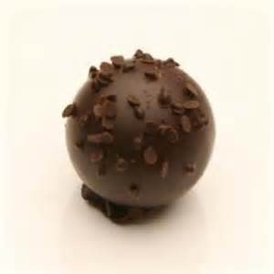
- Dip one third of all ganache balls, one after the other, into Couverture chocolate (using a dipping fork) and place them onto a wire grid
- When the Couverture chocolate begins to set, roll the balls lightly on the grid, using 2 dipping forks to create a spiky appearance, then lift them off and place the truffles onto greaseproof paper to solidify.
White Rum Balls
- Dip the second third of Ganache balls into chocolate and place them into a shallow dish with SIFTED ICING SUGAR
- Roll the Truffles once or twice in the sugar to coat them totally. Allow the Couverture chocolate to harden
- Place the Rum Balls in a coarse sieve and sieve away the excessive icing sugar.
Cocoa Coated Rum Balls
Proceed as for white rum balls, but substitute icing sugar for cocoa powder.

Preparing Chocolate Centres for Enrobing
Marzipan, Walnut Fudge, Puffed Rice Gianduja
- Cut all the slabs out of the holding frame and remove the top layer of plastic or paper
- When the Couverture chocolate has set, place a cutting board on top and flip it over. Remove the plastic or paper
- Cut the marzipan and walnut fudge into rectangles, 2 x3 cm pieces.
Preparation is now complete.

Puffed Rice Gianduja
1. Temper the white Couverture chocolate and spread evenly over the slab. Using a comb scraper make a wavy pattern into the white Couverture chocolate
2. Cut into rectangles, 2 x 3cm pieces before the Couverture chocolate hardens.
Preparation is now complete.

Williams Truffle Sticks
1. Brush the sticks thinly with tempered dark Couverture chocolate
2. When cool, cut into 3 cm long strips using a warm knife or warmed metal scraper.
Preparation is now complete.

Roger Almonds and Truffle Base Cream
No further preparation required.

After Dinner Mints – Peppermint Fondants
1. Brush Couverture chocolate on top.
Preparation is now complete.

Manufacture of Chocolate and Basket Box
Activity
Piping of Chocolate Baskets
Cover a 500 gram margarine container with coloured aluminium foil, press the foil down firmly and fold the ends inside the container.
Place the container, bottom up onto a cake circle and the cake circle onto a decorator’s turntable.
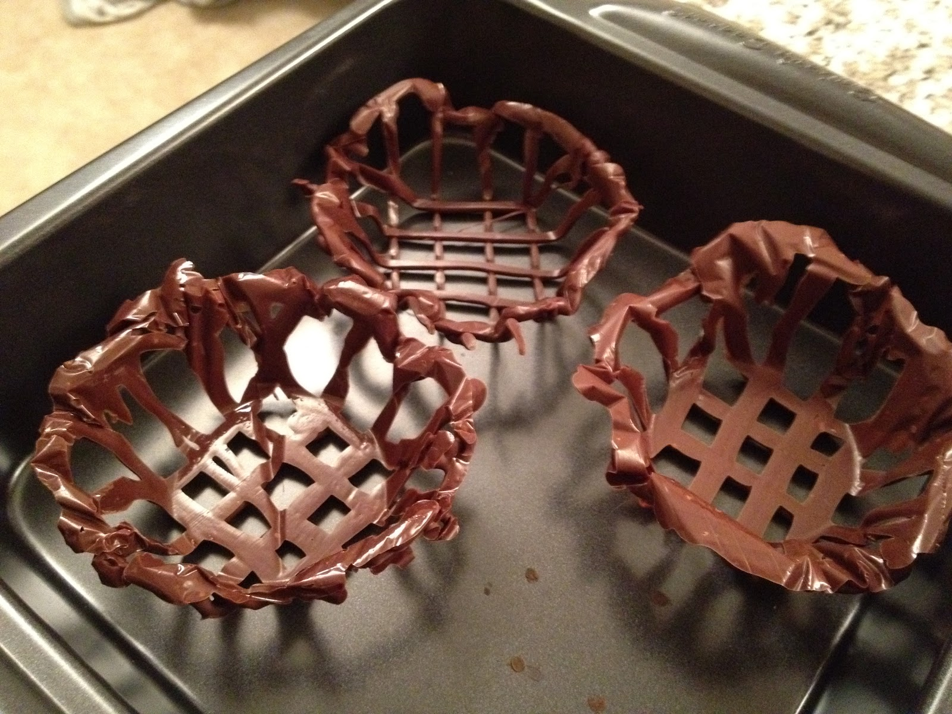
Take a small piping bag, insert a small star tube and fill with thickened piping Couverture chocolate.
Piping Couverture chocolate - Add a little water to the Couverture chocolate and stir until it resembles a soft butter cream.
Recommended Sequence of piping
1. Pipe a lattice pattern onto the bottom part of the foil lined margarine container and a shell border along the rim
2. Pipe a boarder along the bottom
3. Pipe long loops approximately 3 cm wide connecting the top shell border with the bottom shell border
4. The loops should also touch each other on both sides to give the basket stability
5. Pipe 5 rosettes onto the top shell border which will act as ‘legs’ when set
6. ALLOW the Couverture chocolate to set
7. For the handle and using the lid of the margarine container as a guide, draw a semi-circle onto some greaseproof paper
8. Pipe a lightly wavy line on the inside of the semi-circle. Allow to harden, turn over and pipe a second wavy line onto the first one. Allow to harden
9. Turn the Couverture chocolate basket the right way up, turn the foil out and carefully ease the margarine container out. Fold the foil back into the basket
10. Pipe a shell border along the top of the basket. Just before the chocolate hardens, place the handle in position and allow the chocolate to set. For reinforcement, pipe one rosette on to every side of the handle. ALLOW to set
11. Decorate the handle with a bow made from ribbon.

Chocolate Box
1. Temper Couverture chocolate
2. Spread some chocolate, approximately 3mm thick, evenly onto a greaseproof paper or plastic sheet 24 x 20 cm
3. When the chocolate has set, but is not yet hard, cut out 2 squares – 100 x 100mm and 4 strips 90 x 20mm (as per diagram)
4. When the Couverture chocolate has set hard, separate the chocolate pieces
5. To assemble, pipe some Couverture chocolate 4mm inside the outside edge (dotted line on the diagram) and place the 4 Couverture chocolate strips upright onto the Couverture chocolate before it sets
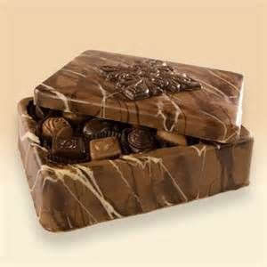
6. Seam and fingerprints on the sides can be hidden by brushing some chocolate onto the outside of the chocolate box creating a rough bark effect
7. The lid can be finished off in the same way or decorated in any tasteful way
8. When all parts are ready, the Couverture chocolate box is then filled with confectionery, the lid placed on top and a broad ribbon and bow attached.

Chocolate Box Template
Bottom | Side 2 | Side 4
 | Side 1 | Side 2
Lid
These can be made any size or shape

Work Projects
It is a requirement of this Unit you complete Work Projects as advised by your Trainer.
You must submit documentation, suitable evidence or other relevant proof of completion of the project to your Trainer by the agreed date.
For this unit the student is going to produce a selection of chocolate products.
The selection should include formed soft centre chocolates; soft centre filled; hard centre enrobed.
How the student provides evidence for these skill demonstrations is to be agreed with the Trainer.
Students need to decide on what is to be their selection of chocolate products and write a menu.
To complete this section the students will have to do the following:
2.1 Make a required filling to match the selection on the menu.
2.2. Make a list of the required equipment required:
- Include all equipment required for both preparation and storage when completed
2.3. Produce the required filling:
- The fillings will be required to be kept at a temperature suitable for depositing or be bought back to such a temperature.

Summary

Prepare chocolate based fillings, coatings and decorations
Select required commodities according to recipe and production requirements
Couverture: properly tempered
Fillings properly prepared according to standard recipes; choices are immense.
Use appropriate equipment to prepare chocolate based fillings, coatings and decorations
All equipment must be dry when working with chocolate. Use equipment in context with the work that is being carried out
Small amount of chocolate: small bowls
Large amount of chocolate: large bowls.
Use correct techniques to produce chocolate based fillings, coatings and decorations to enterprise standards
Techniques need to be practiced and skills developed. This is only achievable with practice; not reading books.
Produce chocolate based fillings/centres, coatings and decorations to enterprise requirements and standards
All centres need to be prepared before beginning the process of making chocolates
Before tempering chocolate be sure all is in place to continue the process
If the chocolate is tempered and process has to stop to make the filling then chocolate sets and then tempering process needs to be done again
Every time couverture is melted it must be re-tempered every time.

Element 3:
Prepare chocolate moulds

3.1 Ensure moulds are clean
It is important that moulds for chocolate moulding are 'scrupulously' clean.
'Scrupulously' means:
- Conscientiously clean
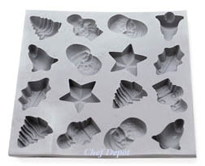
- Obsessive clean
- Cleaning as a religion.
Nothing is more important to the confectioner than the cleanliness of the moulds when moulding chocolate.
If you are not interested in cleaning moulds, stop now.
Moulds can be made of:
- Tinplate
- Stainless steel
- Plastic.
Modern day moulds are all made from polycarbonate or plastic in varying levels of quality.
Moulds or molds were originally made of tinplate. These tinplate moulds were good for the job required but were also very difficult to keep in good condition.
They damaged easily
- If dropped they dent
- If they get wet and not dried sufficiently they rusted
- If surface got scratched the chocolate would adhere to the scratch and stick.
Like all things that the professional uses to produce quality products there are little things that they learn as their experience develops.
One of the characteristics of chocolate is that:
- When it sets it will contract
- Shrink or get smaller in volume.
Comparison
- When water hardens it expands
- When chocolate hardens, it shrinks.
Such is life.
Cleanliness of mould is required for several reasons
Any fingerprints on the inside surface of the mould will show as oil and be dull on surface of chocolate surface.
Any foreign objects, like old pieces of chocolate, from the last moulding still on the surface will cause new molten chocolate to bond and then will not release from surface of the mould.
What caused the original bonding will cause any further chocolate to also bond.
This will cause chocolate to crack when attempting to remove from the mould after shrinking.
Tinplate moulds
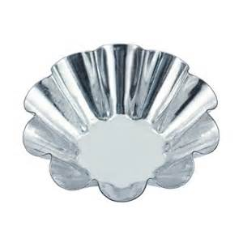
With the tinplate, overtime a thin layer of grease would adhere to the surface of the metal and as long as this was not washed off and the mould was polished clean with a soft cloth.
- It was discovered that it was easy for the chocolate to come away from the surface of the mould as it contracted or shrunk during the cooling process due to this thin layer of grease from the cocoa butter.
Polycarbonate moulds
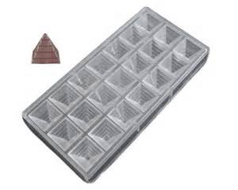
Modern polycarbonate moulds are no different.
The moulds are not susceptible to rusting if they get wet like tinplate but if the moulds are not clean then the chocolate may stick to the mould when the chocolate contracts.
Polycarbonate mould still need to be clean.
The best way to clean polycarbonate is to polish with a soft, no abrasive cloth.
Cotton is best, no nylon; nylon cotton mix may scratch.
Washing polycarbonate moulds
Polycarbonate moulds can be washed but only in warm water with mild hand washing detergent. NOT in the dishwasher.
The dishwasher contain detergent of high alkaline properties that strip away all grease and leaves the surface of the mould stripped back to basic components.
If continually washed the alkaline detergents will eat into the smooth surface of the polycarbonate and they will become pitted.
If chocolate is badly tempered it will stick to the moulds due to improper contraction during cooling process.
It is important not to scratch the surface when attempting to remove chocolate from the moulds.

Best method
Leave moulds in hot water of 50°C for extended period to completely soften all chocolate fats and then wipe them out with soft cloth.
When completely dry the surface of the inside of the mould can be wiped with a soft cloth to remove any surface objects before using.

3.2 Polish moulds ready for use
Moulds can be made from stainless steel, tinplate or various types of plastic, and vary in their flexibility and resistance to shock.
All moulds have to be handled with great care and should only be polished with nonabrasive soft materials.
A soft cotton based cloth or quality cotton wool are best. Be aware that a cheaper quality cotton wool can be rather abrasive.
For chocolates to be easily removed from a mould and to retain a high gloss, it is essential to thoroughly clean and polish each mould.
When applying good work practices, moulds very rarely need to be washed. They can simply be cleaned after every use with a plastic scraper. Never clean with a knife or metal object, as this may cause damage.
While not in use, moulds are best stored upside down to avoid dust particles settling on inside of moulds.

3.3 Keep moulds at correct temperature for production
To prepare moulds for use they are best warmed:
- 25°C for metal
- 20°C for polycarbonate.
This is best done in specific warming cabinet for holding moulds before filling.

Work Projects
It is a requirement of this Unit you complete Work Projects as advised by your Trainer.
You must submit documentation, suitable evidence or other relevant proof of completion of the project to your Trainer by the agreed date.
For this unit the student is going to produce a selection of chocolate products.
The selection should include formed soft centre chocolates; soft centre filled; hard centre enrobed.
How the student provides evidence for these skill demonstrations is to be agreed with the Trainer.
To provide the information for this section the students will have to do the following:
3.1 Clean chocolate moulds:
- Remove any unwanted matter.
3.2. Polish mould ready for use:
- Ensure all inside surfaces are clear of foreign matter that may cause imperfections.
3.3. Warm the mould ready to be filled:
- Polycarbonate can be stored in controlled atmosphere cupboard to keep at temperature of 20°C
- Assists in keeping dry.

Summary

Prepare chocolate moulds
Ensure moulds are clean
Cleaning of the moulds is the most unpopular job in chocolate making.
But they need to be clean.
Wash in warm water with mild detergent and soft cloth, lint free cloth like cheesecloth.
Allow to air dry, maybe use hair dryer to speed process but they must be perfectly dry when chocolate is poured into moulds.
Polish moulds ready for use
Some will say that polishing mould is best way to clean moulds.
Polishing is best way to remove any last vestiges of foreign objects from the mould.
Polish with lint free cotton; cheesecloth. There are many thoughts on this.
Moulds are kept at correct temperature for production
After cleaning, drying and polishing polycarbonate moulds they are best stored in warming cabinet so they are ready for the next use.
Warming cabinets are similar to bread proofers in that they have a constant temperature, 20°C for polycarbonate.
Even in warmer climates these cabinets are ideal for storing moulds.
Ready for future use.

Element 4:
Make moulded chocolates

4.1 Select and prepare combinations to be produced

Introduction
How long is a piece of string?
Overtime and will many failures chocolate flavour combinations have been developed.
The confectioner might like a specific flavour combination BUT if the purchasing public do not like that flavour then is will not sell.
What combinations to uses
Chocolates enemy is moisture.
Any flavouring has to be able to be blended into the chocolate with no moisture included.
- It can have a fat content like milk powder but not milk which contains water
- Volatile oils can be used as with citrus flavours
- Alcohol can be used but not.
Cream can be used in filling but not in the chocolate couverture itself.
Flavours that work well in Chocolate couverture
Alcohol:
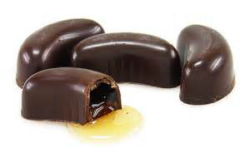
- Whisky
- Dark Rum
- Orange liqueurs
- Brandy.
Non-Alcohol Flavours:
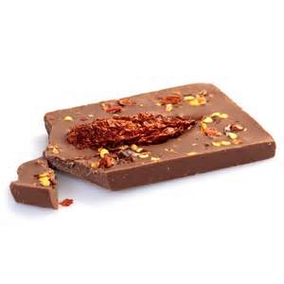
- Coffee or coffee bean nibs
- Citrus oils
- Salt
- Spices like cinnamon; nutmeg; ginger; cloves; alone or as Gingerbread spice mix
- Chilli
- Lavender flowers.

4.2 Use tempered couverture and set in moulds correctly

About Chocolate Moulds
Moulds can be made from stainless steel, tinplate or various types of plastic, and vary in their flexibility and resistance to shock.
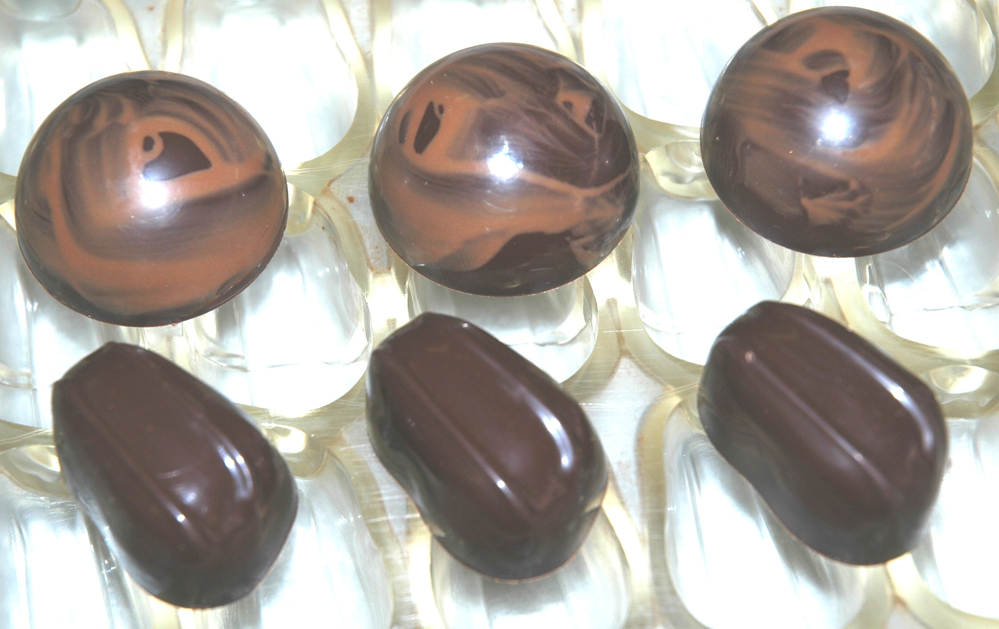
All moulds have to be handled with great care and should only be polished with nonabrasive soft materials.
A soft cotton based cloth or quality cotton wool are best. Be aware that a cheaper quality cotton wool can be rather abrasive.
For chocolates to be easily removed from a mould and to retain a high gloss, it is essential to thoroughly clean and polish each mould.
When applying good work practices, moulds very rarely need to be washed.
They can simply be cleaned after every use with a plastic scraper. Never clean with a knife or metal object, as this may cause damage. If necessary wash in warm water (maximum 50°C) and dry thoroughly.
While not in use, moulds are best stored upside down to avoid dust particles depositing.

Lining the moulds
Moulds have to be dry, cleaned and polished and be at a temperature of 25°C (metal) or 20°C (plastic).
To line a mould, it is filled with tempered chocolate and the excess scraped off.
To help trapped air bubbles to escape, the mould is now vibrated or tapped repeatedly with an appropriately sized piece of wood (e.g. a piece of broom handle).
The mould should be turned upside down over the chocolate container, allowing the excess to run out, shaking the mould at the same time until the lining is of the required thickness.
The mould is now turned back into its upright position. Using a plastic spatula or scraper, clean the upright surface of the mould.
To set the chocolate, the mould should be turned on its side or turned upside down onto silicon or greaseproof paper. When set, remaining spills are removed.
If the initial coat is too thin, line with a second layer of chocolate.
The moulds can now be filled or cooled in a refrigerator until the lining comes loose, and then be filled.

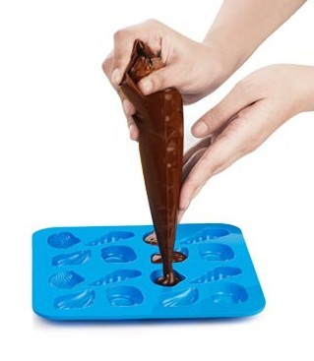
4.3 Fill moulded chocolates correctly

Filling the moulds
The fillings should be of a temperature and consistency where they can be rationally piped into the shells.
This may require slight warming to soften the fat component. Care must be taken not to heat the fillings to a point where it will affect or soften the chocolate lining.
The piping technique applied should result in the filling being level and about 2 mm below the rim:
- Precise and clean work is of utmost importance.
The moulds are finished off by applying a coat of tempered chocolate, scraping off the excess with a spatula. Spills on the sides of a mould are to be cleaned up.

4.4 Set, release and handle moulded chocolates appropriately
Given time, chocolate will contract on cooling. This process can be helped along by placing the moulds into a refrigerator set not lower than 10°C.
Cooler temperatures may give the chocolate a thermal shock, resulting in undesirable characteristics (discoloured streaks or blotchy marks).

Demoulding
To remove the chocolates, turn the moulds upside down on to a greaseproof paper-lined tray, or another clean and dry area reserved for chocolate work.
Top quality Polycarbonate moulds are quite strong and thick. When de-moulding a sharp short tap on the bench top will dislodge chocolates from mould.
Caution
Care needs to be taken when tapping on bench that the edge of the bench is not used.
The chocolates just end up on the floor.
Properly prepared chocolates should be of a high gloss finish, free from any blemishes and flat and level on the bottom.
Handling after de-moulding
To avoid fingerprints and marks, lint-free cotton or thin plastic or nylon cotton gloves should be worn whenever the chocolates are handled:
- Human skin exudes oils all the time so take care when handling chocolates.
All chocolates and chocolate products should be stored in a dry, odour-free area at about 18°C.
When demoulded, the chocolates should be placed onto clean storage trays until required for display.
Work Projects
It is a requirement of this Unit you complete Work Projects as advised by your Trainer.
You must submit documentation, suitable evidence or other relevant proof of completion of the project to your Trainer by the agreed date.
For this unit the student is going to produce a selection of chocolate products.
The selection should include formed soft centre chocolates; soft centre filled; hard centre enrobed.
How the student provides evidence for these skill demonstrations is to be agreed with the Trainer.
The student will have to fulfil the following requirements
4.1 Select several recipes that they will use:
- Soft centres of various flavours and styles.
4.2. Temper required amount of couverture and make chocolate shell ready for filling:
- Care needs to be taken not to allow condensation to come in contact with the chocolate.
4.3. Fill empty shell with required amount of filling and seal with more tempered chocolate:
- When covering ensure that a clean seal is achieved.
4.4. Allow chocolates to set then remove or release from moulds:
- Do not try to release until chocolate has contracted away from surface of mould.

Summary

Make moulded chocolates
Select and prepare combinations to be produced
Choose recipes required
Gather all ingredients before commencing.
Use tempered couverture and set in moulds correctly
Apply tempered chocolate to moulds
Achieve clean edges to moulds.
Fill moulded chocolates correctly
Fill with required amount of filling
Seal with appropriate amount of tempered chocolate to achieve good seal on bottom.
Set, release and handle moulded chocolates appropriately
Allow to set then remove from moulds
Release by turning polycarbonate mould over and giving a sharp tap to edge of mould on bench
Do not tap on edge of bench as the chocolates will fall on floor
Handle de-moulded chocolate with covered hands
Fingers will leave an imprint of oil from skin.

Element 5:
Coat and decorate with chocolate

5.1 Prepare a variety of chocolate coating, icing, glazes and decorations

Introduction
Decorations to chocolates can be applied after they have been dipped or enrobed.
If the decoration is wet like another colour chocolate it can be applied after the chocolate has set firm. The second chocolate applied with small piping bag.
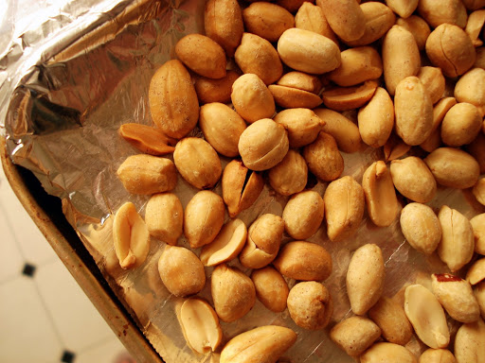
If the decoration is dry it must be applied while the coating chocolate is wet so it will bind to the setting chocolate.

Dry Decorations
Roasted nuts
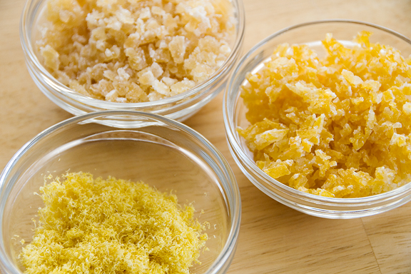
All nuts should be roasted as it has a better flavour and cooks the oil present in the nut. Care must be taken not to burn the nuts as this will make them bitter.
These nuts should be cut in half or smaller pieces. This allows for greater spread of the cost.
Flowers
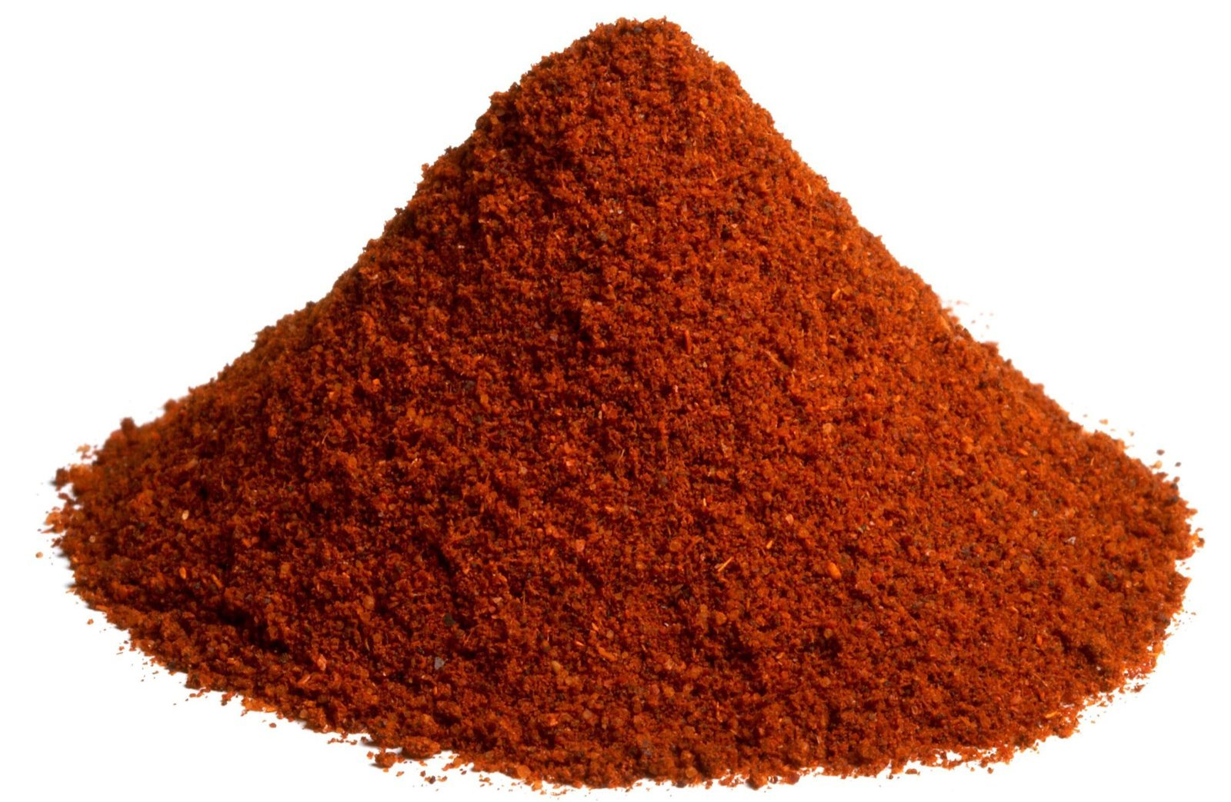
Lavender flowers can be dropped on top and have a pleasant taste.
Candied citrus peels and Ginger
Cut into small pieces these can be placed on top.
Roasted Chilli powder
Any spices should be treated with some high heat to reduce bacterial activity and impart and improved flavour.

5.2 Decorate using coating, icing, glazes and decorations according to standard recipes and/or enterprise standards and/or customer requests

Introduction
As with all formulae; every step must be written into the methods of preparation.
Any decoration needs to be applied as outlined in the Standard recipe.
Pictures help as they have a visual example of the written word.
All modern recipes should have a picture.
A better example is step pictures or a small video.
Many examples are now available on the internet and students are advised to access these to assist in their learning.
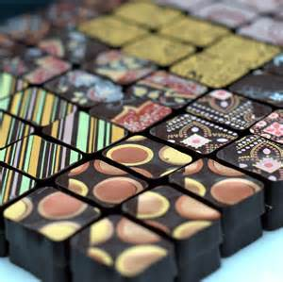
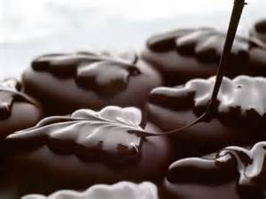
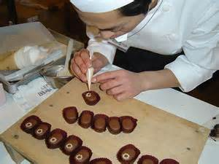
Work Projects
It is a requirement of this Unit you complete Work Projects as advised by your Trainer.
You must submit documentation, suitable evidence or other relevant proof of completion of the project to your Trainer by the agreed date.
For this unit the student is going to produce a selection of chocolate products.
The selection should include formed soft centre chocolates; soft centre filled; hard centre enrobed.
How the student provides evidence for these skill demonstrations is to be agreed with the Trainer.
The following will need to be achieved:
5.1 Prepare any glazes that may be required according to standard recipe.
5.2. Decorate all chocolates as prescribed in standard recipe.

Summary

Coat and decorate with chocolate
Prepare a variety of chocolate coating, icing, glazes and decorations
Follow the Standard recipe and produce as required
Very little glazing or icings are provided for couverture chocolates.
Decorate using coating, icing, glazes and decorations according to standard recipes and/or enterprise standards and/or customer requests
Many decorations can be used but sometimes the natural sheen or shine of the chocolate is sufficient
High value chocolates have minimal decorations
It is the gloss of good quality Couverture chocolate is the main 'eye appeal' and the eating 'mouth-feel' flavour that lingers long time in the mouth
Decorations are not mandatory
They just act as visual stimuli to the display of the product.

Element 6:
Store chocolate and chocolate products

6.1 Store at correct temperature and conditions

Introduction

Storage
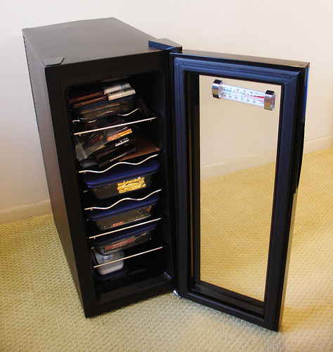
Storage temperature: 15°C – 18°C
Expert preparation of chocolate begins with proper storage.
Large variations of temperature affect the fine chocolate aroma and create condensation.
Therefore, protect your chocolate from temperature changes, light, foreign odours, warmth and humidity.
When chocolate arrives at the processing area (kitchen etc.) from its storage area, the difference in temperature must not exceed 6°C – 7°C.
Sudden changes in temperature can cause moisture to form on surface of chocolate mass.
Chocolate should always be kept wrapped in the paper in which it arrived from the manufacturer.
24°C seems to be the critical temperature for chocolate. This is the temperature at which the lower-melting fractions of the cocoa butter begin to melt and rise to the surface.
The heavier cocoa and sugar particles sink to the bottom of the mass of chocolate and cause the fat bloom.
Too moist an atmosphere is harmful due to the risk of condensation forming on the surface and causing sugar bloom.

6.2 Maintain maximum eating quality, appearance and freshness
Chocolate has relative low moisture content so bacterial activity is negligible.
To maintain freshness when storing chocolate it is recommended that the area be a relative temperature of 15°C to 18°C.
The humidity should be low and with no air movement.
Quality confectionary chocolate outlets will store finished product in glass encased shelving.
When not trading, chocolates should be covered to protect against light.
Exposure to heat and sunlight is detrimental to the sheen that is required from quality chocolates.
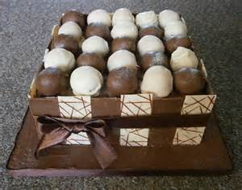
Appearance
To maintain appearance all finished product should be handled with gloved hands.
No bare fingers
This is because the human body exudes oils all the time in perspiration and it will leave a 'fingerprint' the chocolate is handled with bare skin.
Freshness
Freshness is maintained by turning over the finished product as quickly as possible.
'Turning over' means selling as quickly after manufacturing as possible.

Work Projects
It is a requirement of this Unit you complete Work Projects as advised by your Trainer.
You must submit documentation, suitable evidence or other relevant proof of completion of the project to your Trainer by the agreed date.
For this unit the student is going to produce a selection of chocolate products.
The selection should include formed soft centre chocolates; soft centre filled; hard centre enrobed.
How the student provides evidence for these skill demonstrations is to be agreed with the Trainer.
Part of the information supplied to Trainer will need to include the following information.
6.1 How is chocolate to be stored:
- Define the parameters that will need to be met for the ideal storage of chocolate.
6.2. Define the best way to keep chocolate and chocolate products in best condition:
- Describe how the freshness of the chocolate is going to be accomplished.

Summary

Store chocolate and chocolate products
Store at correct temperature and conditions
Store chocolate at between 15°C and 18°C
Keep protected from outside contamination
Store in dry cool environment.
Maintain maximum eating quality, appearance and freshness
Eating quality is directly affected by how the chocolate is stored
Appearance is affected by how it is processed and how long it is stored and the condition in which it is stored
Best advice for freshness is to make only what can be sold within a short cycle:
Weekly or fortnightly
Good quality chocolate should be fresh.

Presentation of written work

1. Introduction
It is important for students to present carefully prepared written work. Written presentation in industry must be professional in appearance and accurate in content. If students develop good writing skills whilst studying, they are able to easily transfer those skills to the workplace.

2. Style

Students should write in a style that is simple and concise. Short sentences and paragraphs are easier to read and understand. It helps to write a plan and at least one draft of the written work so that the final product will be well organised. The points presented will then follow a logical sequence and be relevant. Students should frequently refer to the question asked, to keep ‘on track’. Teachers recognise and are critical of work that does not answer the question, or is ‘padded’ with irrelevant material. In summary, remember to:
- Plan ahead
- Be clear and concise
- Answer the question
- Proofread the final draft.

3. Presenting Written Work
Types of written work
Students may be asked to write:
- Short and long reports
- Essays
- Records of interviews
- Questionnaires
- Business letters
- Resumes.
Format
All written work should be presented on A4 paper, single-sided with a left-hand margin. If work is word-processed, one-and-a-half or double spacing should be used. Handwritten work must be legible and should also be well spaced to allow for ease of reading. New paragraphs should not be indented but should be separated by a space. Pages must be numbered. If headings are also to be numbered, students should use a logical and sequential system of numbering.
Cover Sheet
All written work should be submitted with a cover sheet stapled to the front that contains:
- The student’s name and student number
- The name of the class/unit
- The due date of the work
- The title of the work
- The teacher’s name
- A signed declaration that the work does not involve plagiarism.
Keeping a Copy
Students must keep a copy of the written work in case it is lost. This rarely happens but it can be disastrous if a copy has not been kept.
Inclusive language
This means language that includes every section of the population. For instance, if a student were to write ‘A nurse is responsible for the patients in her care at all times’ it would be implying that all nurses are female and would be excluding male nurses.
Examples of appropriate language are shown on the right:
Mankind | Humankind
Barman/maid | Bar attendant
Host/hostess | Host
Waiter/waitress | Waiter or waiting staff

Recommended reading
Bloom,Carole ;2009; Bite-Size Desserts: Creating Mini Sweet Treats, from Cupcakes to Cobblers to Custards and Cookies; Houghton Mifflin Harcourt
Curry, William; 2011; Couture Chocolate; Penguin Group
Dodge, Abigail Johnson; 2012; Mini Treats & Hand-Held Sweets: 100 Delicious Desserts to Pick Up and Eat; Taunton Press
Forster, Felicity; 2010; 300 Chocolate Desserts and Treats: Rich recipes for hot and cold desserts, ice creams, tarts, pies, candies, bars, truffles and drinks; Anness
Friberg, Bo; 2004 (4th edition); The Professional Pastrychef; Van Nostrand Reinhold
Goodman, Clio & Sussman, Adeena; 2013; Puddin': Luscious and Unforgettable Puddings, Parfaits, Pudding Cakes, Pies, and Pops; Spiegel & Grau
Greweling, Peter; 2012; Chocolates and Confections: Formula, Theory, and Technique for the Artisan Confectioner; Wiley
Greweling, Peter; 2006; Chocolates and Confections; John Wiley and Sons
Ojakangas, Beatrice; 2009; Petite Sweets: Bite-Size Desserts to Satisfy Every Sweet Tooth; Sellers Publishing, Inc
Roux, Michel; 1996; Desserts, A Life Long Passion; Conran Octopus Limited
Shortland, Kemberlee; 2013 (Kindle Edition); Just Desserts; Tirgearr Publishing
Shotts, Andrew Garrison; 2007; Making Artisan Chocolates; Quarry Books
Styler.Christopher; 2006; Working the Plate: The Art of Food Presentation; Houghton Mifflin Harcourt

Trainee evaluation sheet

Prepare chocolate and produce chocolate products
The following statements are about the competency you have just completed.
Please tick the appropriate box | Agree | Don’t Know | Do Not Agree | Does Not Apply
There was too much in this competency to cover without rushing.
Most of the competency seemed relevant to me.
The competency was at the right level for me.
I got enough help from my trainer.
The amount of activities was sufficient.
The competency allowed me to use my own initiative.
My training was well-organised.
My trainer had time to answer my questions.
I understood how I was going to be assessed.
I was given enough time to practice.
My trainer feedback was useful.
Enough equipment was available and it worked well.
The activities were too hard for me.

The best things about this unit were:

The worst things about this unit were:

The things you should change in this unit are:

Trainee Self-Assessment Checklist
As an indicator to your Trainer/Assessor of your readiness for assessment in this unit please complete the following and hand to your Trainer/Assessor.

Prepare chocolate and produce chocolate products
 |  | Yes | No*
Element 1: Temper couverture
1.1 | Melt and temper couverture using correct techniques and temperatures
1.2 | Maintain tempered couverture for use
Element 2: Prepare chocolate based fillings, coatings and decorations
2.1 | Select required commodities according to recipe and production requirements
2.2 | Use appropriate equipment to prepare chocolate based fillings, coatings and decorations
2.3 | Use correct techniques to produce chocolate based fillings, coatings and decorations to enterprise standards
2.4 | Produce chocolate based fillings/centres, coatings and decorations to enterprise requirements and standards
Element 3: Prepare chocolate moulds
3.1 | Ensure moulds are clean
3.2 | Polish moulds ready for use
3.3 | Keep moulds at correct temperature for production
Element 4: Make moulded chocolates
4.1 | Select and prepare combinations to be produced
4.2 | Use tempered couverture and set in moulds correctly
4.3 | Fill moulded chocolates correctly
4.4 | Set, release and handle moulded chocolates appropriately
Element 5: Coat and decorate with chocolate
5.1 | Prepare a variety of chocolate coating, icing, glazes and decorations
5.2 | Decorate using coating, icing, glazes and decorations according to standard recipes and/or enterprise standards and/or customer requests
Element 6: Store chocolate and chocolate products
6.1 | Store at correct temperature and conditions
6.2 | Maintain maximum eating quality, appearance and freshness

Statement by Trainee:
I believe I am ready to be assessed on the following as indicated above:
Signed: | _____________________________ | Date: | ______ / ______ / ______
Note:
For all boxes where a No* is ticked, please provide details of the extra steps or work you need to do to become ready for assessment.





